**Assignment-12**

**Problem Statement: Deploy and run the project in AWS without using port**

**Steps:-**

1. Sign-in to the console and Click to the EC2

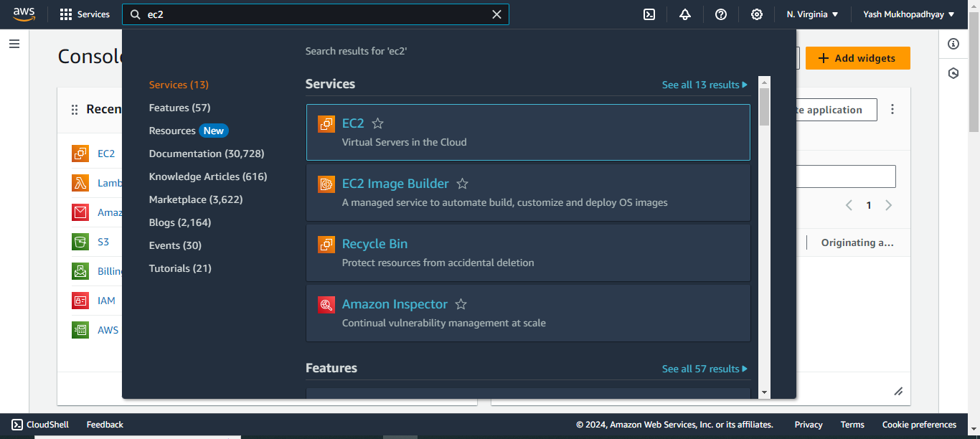

1. click on security group.

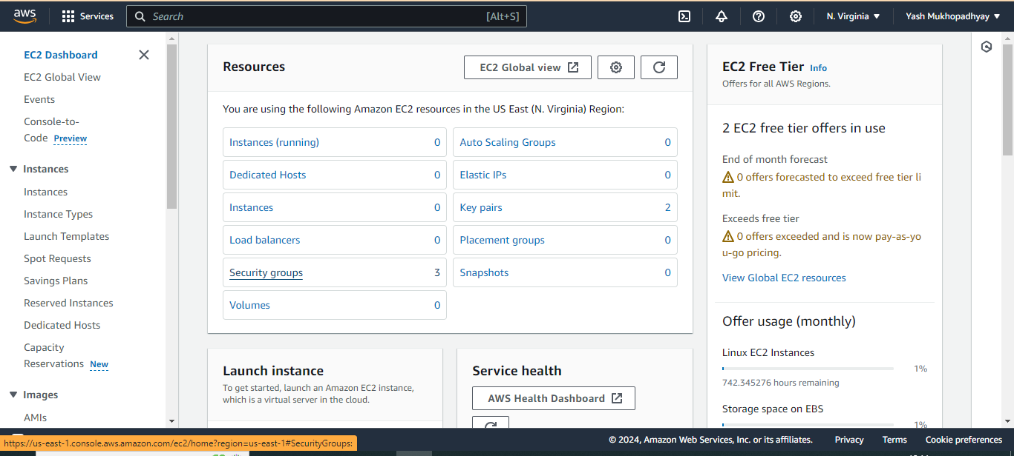

1. Click on Create Security Group

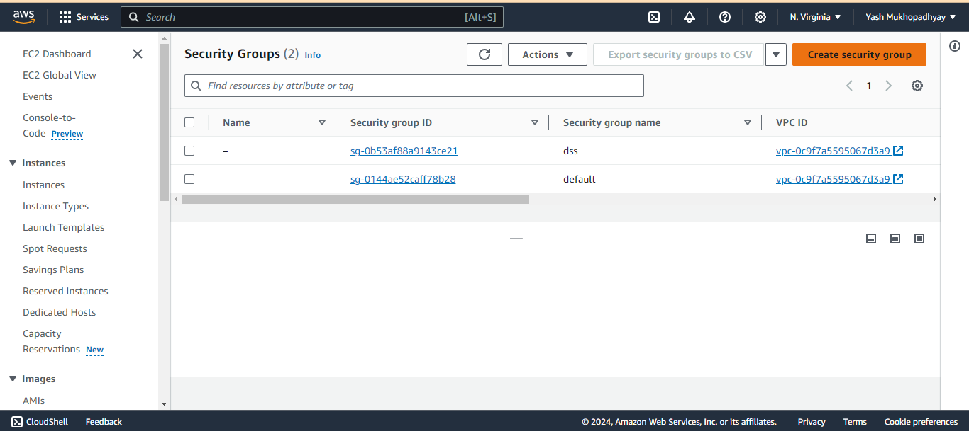

1. Now give proper name and description.

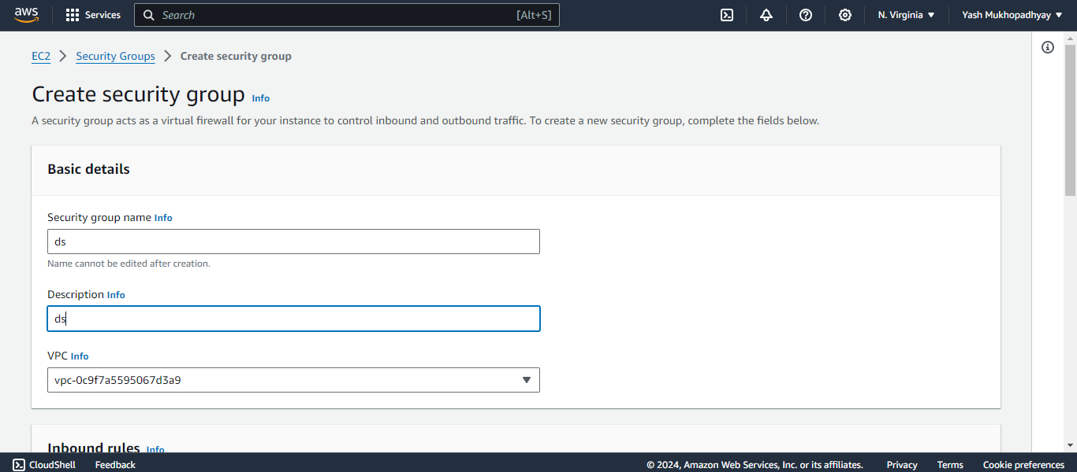

1. Now in inbound rules click on Add rule and in this way add 4 security rules of Custom TCP,SSH,HTTP,HTTPS.

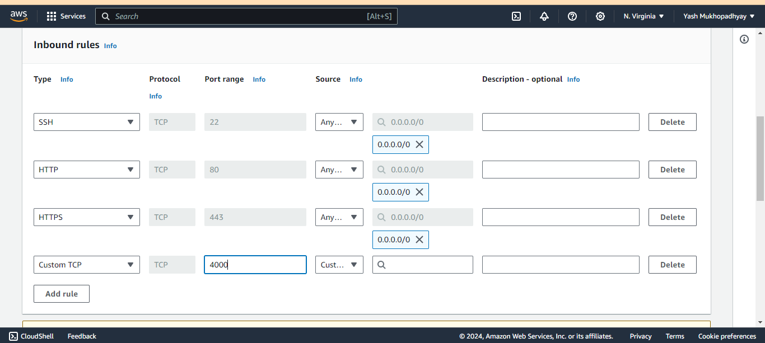

1. Now click on Create Security Group.

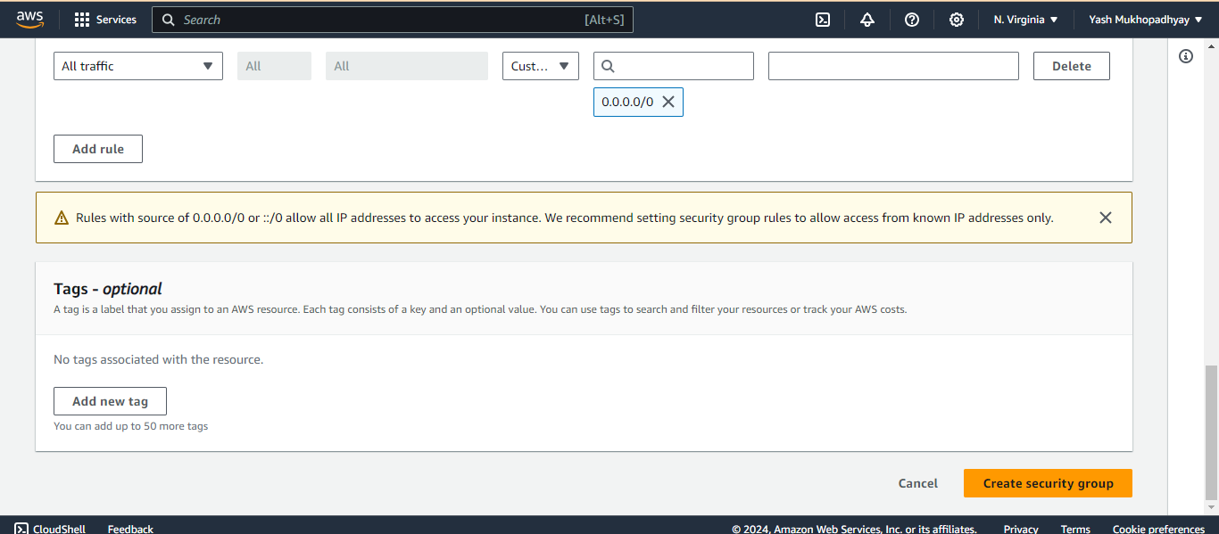

1. Now under the EC2 Dashboard click on Lauch Instance.

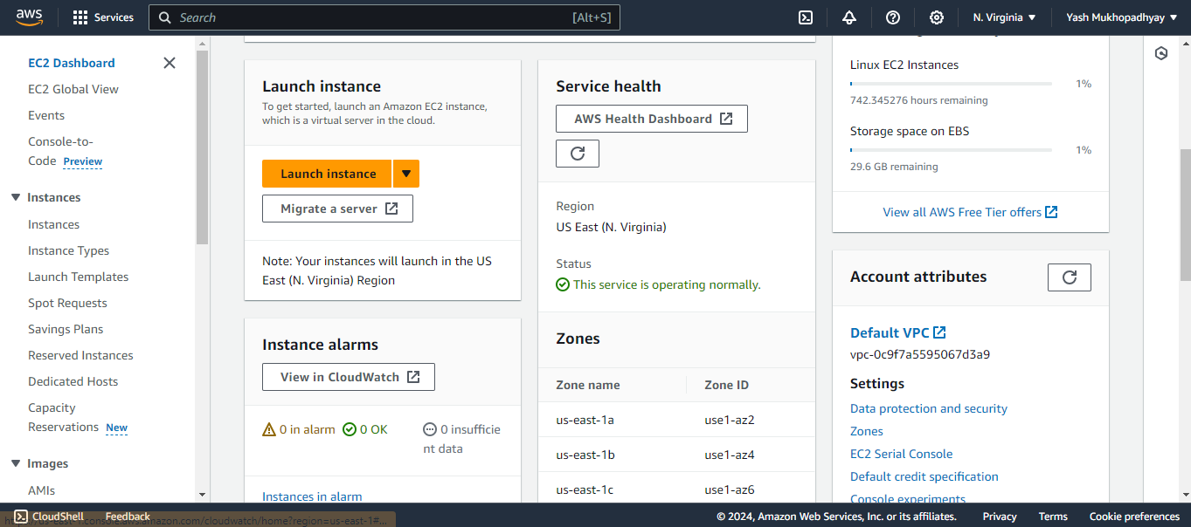

1. Give a name and click on Ubuntu under Quick Start.

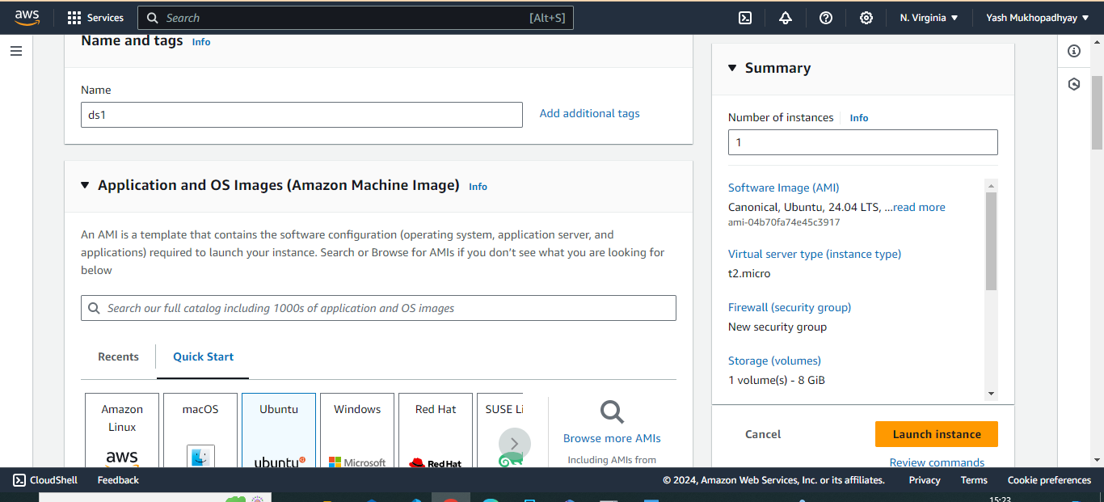

1. Now under the Key Pair,Select the Key pair you have or create a new key pair

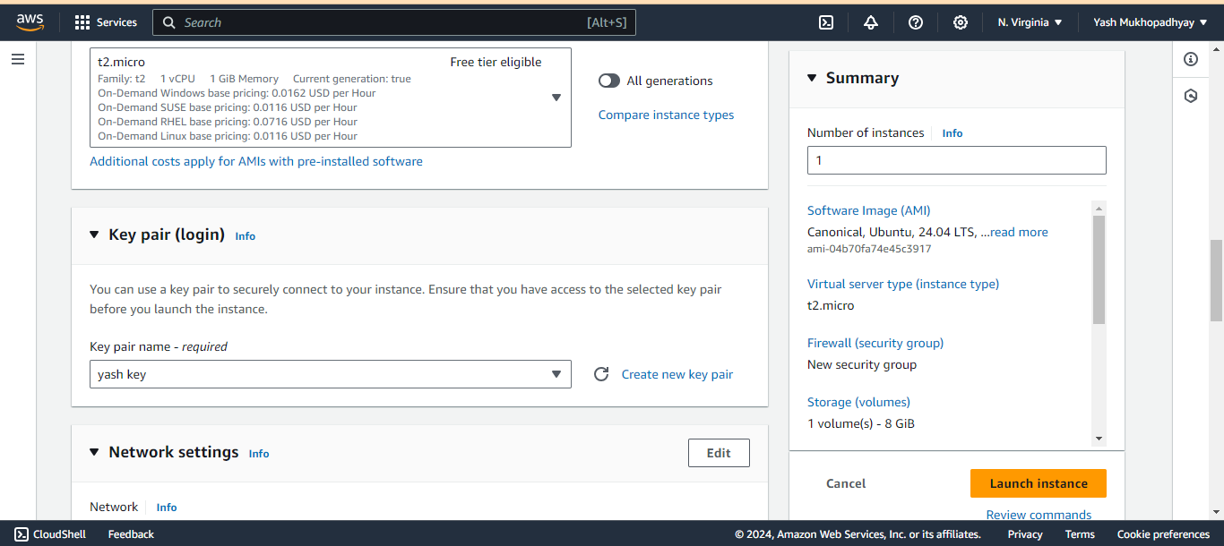

1. Now Navigate to the Network Settings and select “select existing security group”. Then finally click “Launch Instance”.

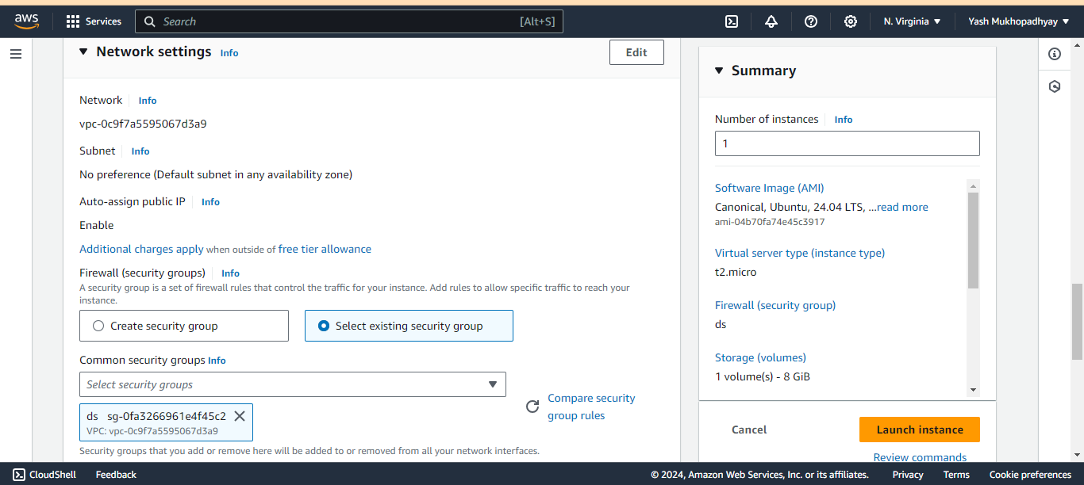

1. Click on instance and copy public IPv4 address

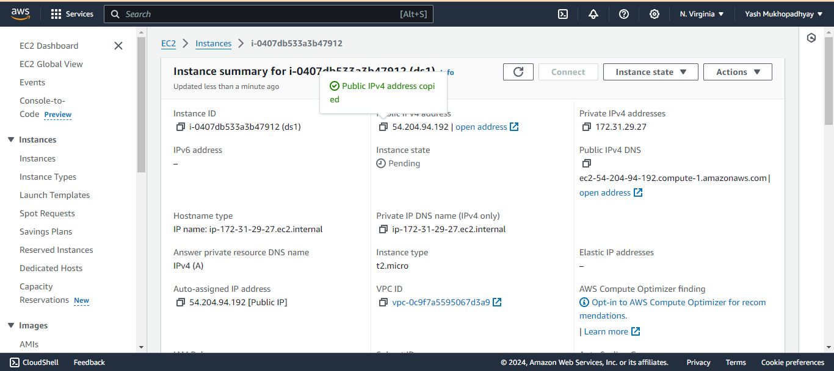

1. Paste it in host of BitVise SSH client

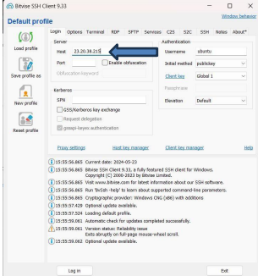

1. click on the client key manager and import the key.

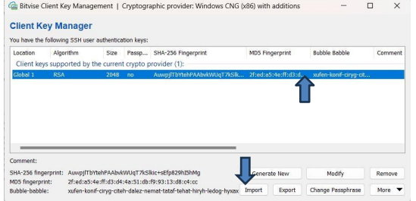

1. click on login and choose accept and save.

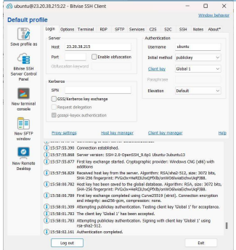

1. Now open terminal after login and then write all these commands :

* pwd
* sudo apt -get update
* sudo apt -get upgrade
* sudo apt-get install nginx
* curl –SL https://deb.nodesource.com/setup_16.x|sudo -E bash –
* sudo apt install nodejs
* git clone <https://github.com/yash2870/sample.git>
* cd sample
* npm install
* node index.js



1. Now server has started. If we paste the ipv4 address in url section then we can see nginx has started. To stop server click (ctrl+c).

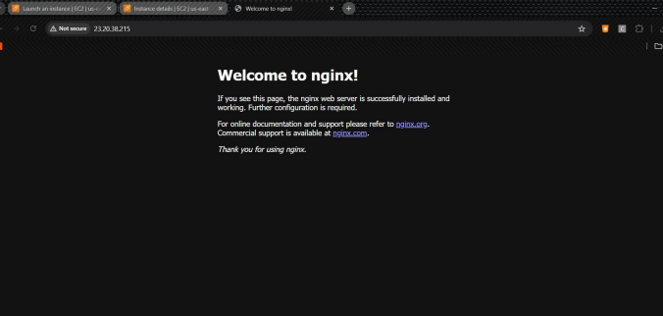

1. Now write these all commands:

* Cd /
* pwd
* cd etc/nginx/sites-available/

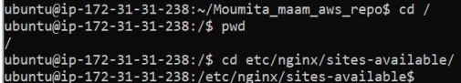

1. Now type sudo nano default to open GNU editor.

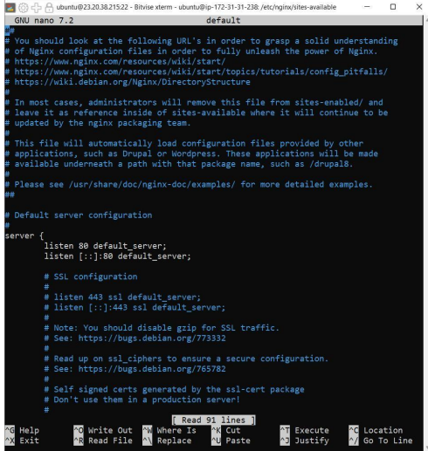

1. There at first go to location area and comment all codes and the write:

location / { proxy_pass <http://localhost:4000>;

proxy_http_version 1.1;

proxy_set_header Upgrade $http_upgrade;

proxy_set_header Connection 'upgrade';

proxy_set_header Host $host;

proxy_cache_bypass $http_upgrade;

}

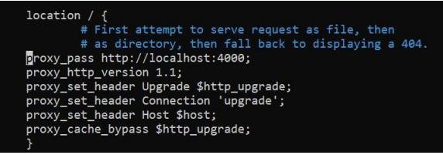

1. After this click ctrl+x, then y then click enter.
2. Now open new terminal and write cd sample.
3. Write sudo systemctl restart nginx.
4. Now copy that public IPv4 address again and paste it in url and there you can see that without giving port(:4000) with url we have hosted the website.



**INFERENCES:**

1. A security group with necessary inbound rules (Custom TCP, SSH, HTTP, HTTPS) is created and associated with an EC2 instance running Ubuntu.

2. The instance is launched with a specified key pair, and its public IPv4 address is used for SSH access via BitVise.

3. Essential updates, Nginx, Node.js, and a sample application are installed and configured on the instance.

4. Nginx is set up as a reverse proxy to forward requests to the Node.js application running on localhost:4000.

5. The application is successfully accessed through the public IPv4 address without specifying a port, confirming proper configuration.